Sprint Retrospective – 01.05

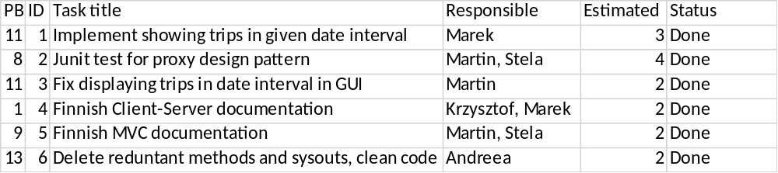
During this sprint we have finished all the coding tasks. We have created Junit test to test proxy design pattern. We have also finished client-server and MVC documentations. After all this was finished we ran inspection on the code using which we have found and deleted all reduntant methods and sysouts from the code.

